Name Date

- Find and draw all lines of symmetry in the following figures. If there are none, write “none.”
a.
c.
b.
f.
e.
d.

g.
For each triangle above, state whether it is acute, obtuse, or right and whether it is isosceles, equilateral, or scalene.

Triangle a: _________________________ _________________________
Triangle c: _________________________ _________________________
Triangle e: ____________________ _____ _________________________
h.
How many lines of symmetry does a circle have? What point do all lines of symmetry for a given circle have in common?
____________________________________________________________________________________________________________________________________________________________________________________________________________________________

- In the following figure QRST is a rectangle. Without using a protractor, determine the measure of ∠RQS. Write an equation that could be used to solve the problem.
24°
Q
T
S
R

- For each part below, explain how the measure of the unknown angle can be found without using a protractor.

- Find the measure of $∠$D.
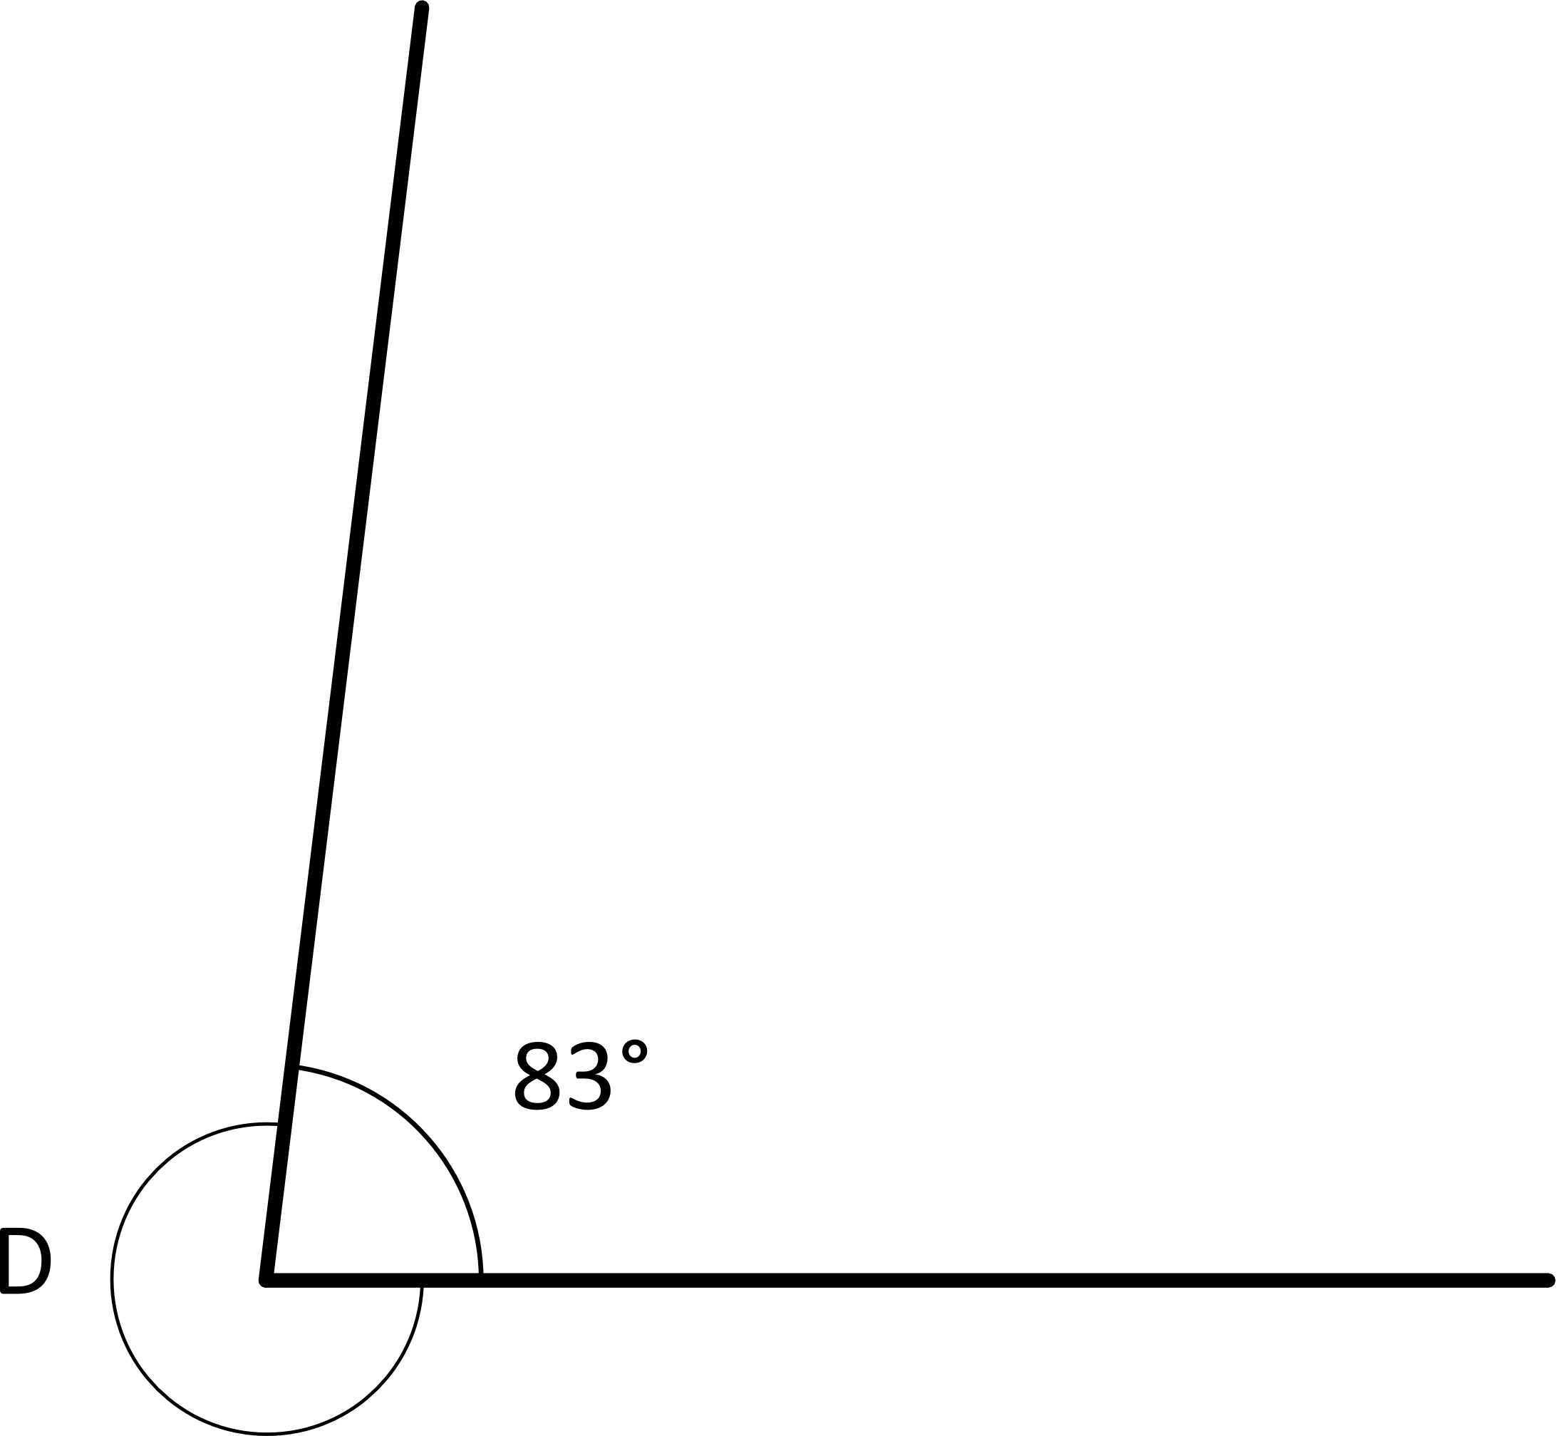

- In this figure, Q, R, and S lie on a line. Find the measure of $∠\text{QRT}$.
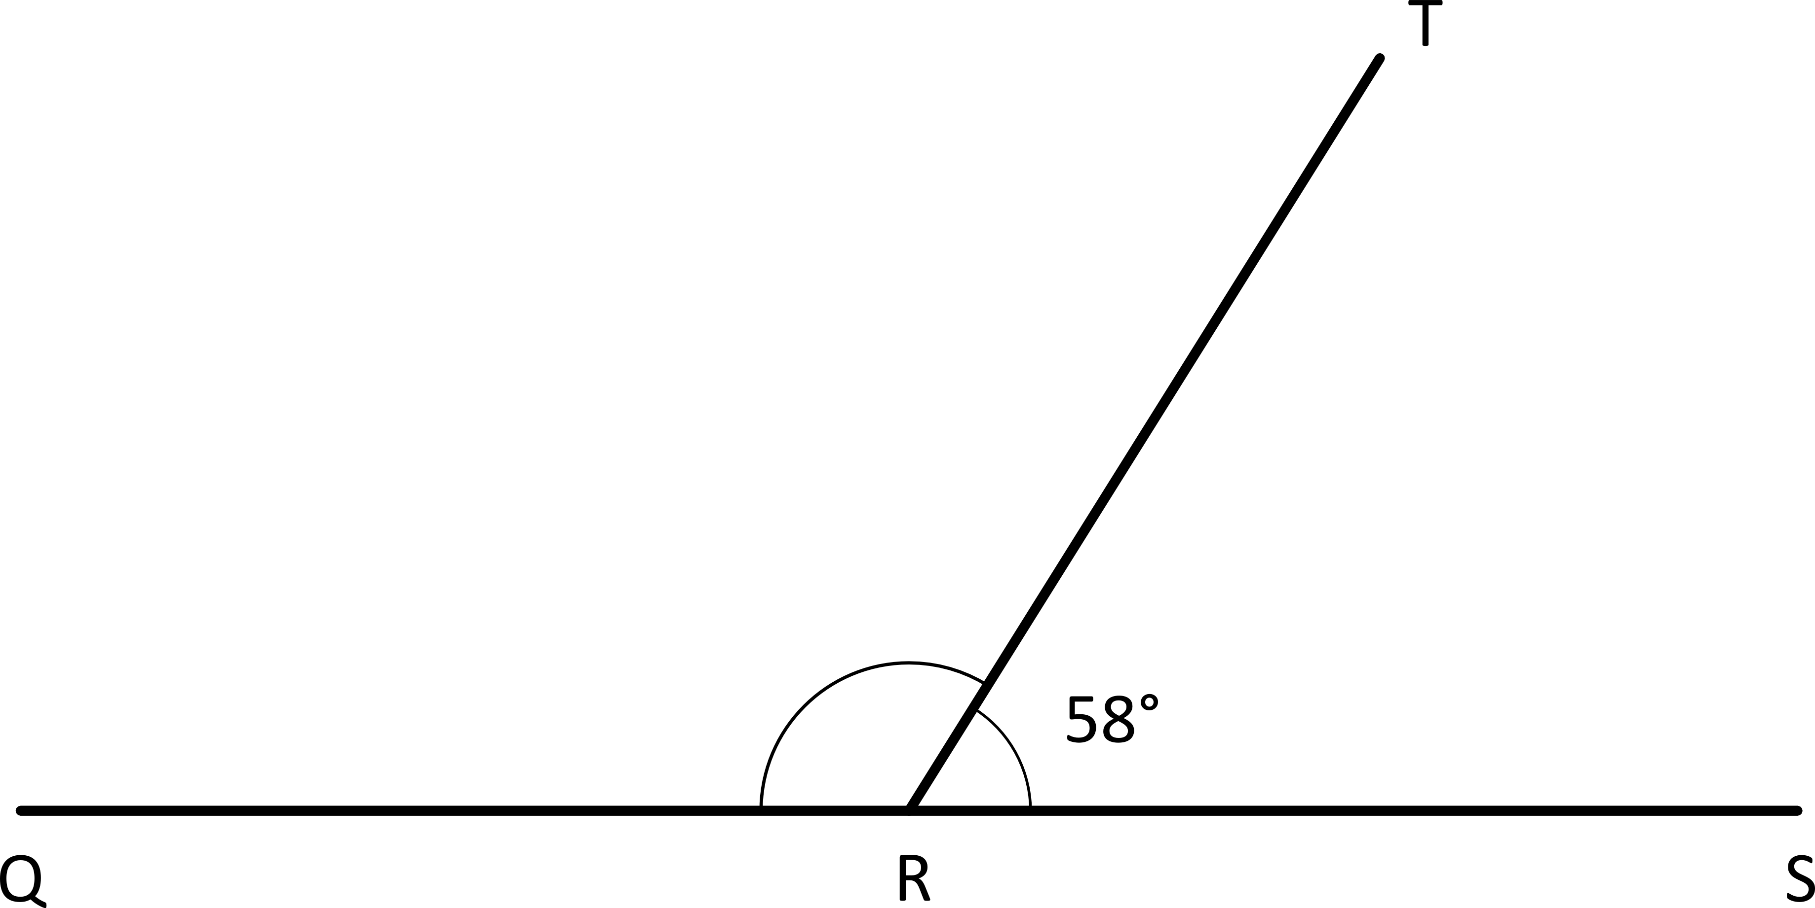

- Q, R, and S lie on a line, as do P, R, and T. Find the measure of $∠$PRS.
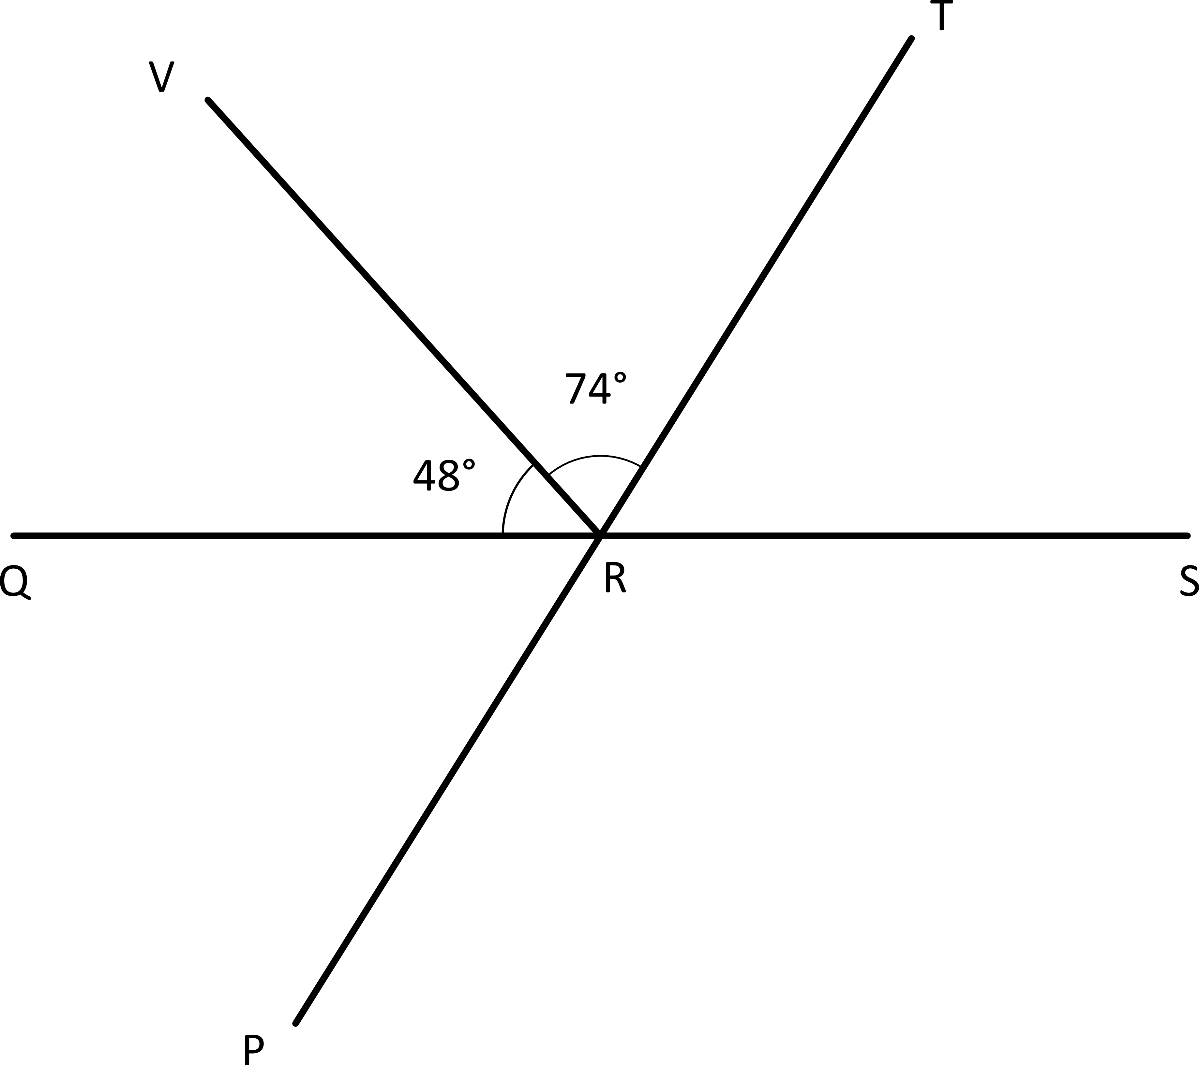

- Mike drew some two-dimensional figures.
Sketch the figures and answer each part about the figures that Mike drew.
  - He drew a four-sided figure with four right angles. It is 4 cm long and 3 cm wide.
What type of quadrilateral did Mike draw?
How many lines of symmetry does it have?

  - He drew a quadrilateral with four equal sides and no right angles.
What type of quadrilateral did Mike draw?
How many lines of symmetry does it have?

  - He drew a triangle with one right angle and sides that measure 6 cm, 8 cm, and 10 cm.
Classify the type of triangle Mike drew based on side length and angle measure.
How many lines of symmetry does it have?

  - Using the dimensions given, draw the same shape Mike drew in Part (c).

  - Mike drew this figure. Without using a protractor, find the sum of $∠$FJK, $∠$KJH, and $∠$HJG.
J
F
G
K
H

  - Points F, J, and H lie on a line. What is the measure of $∠$KJH if $∠$FJK measures 45 degrees? Write an equation that could be used to determine the measure of $∠$KJH.

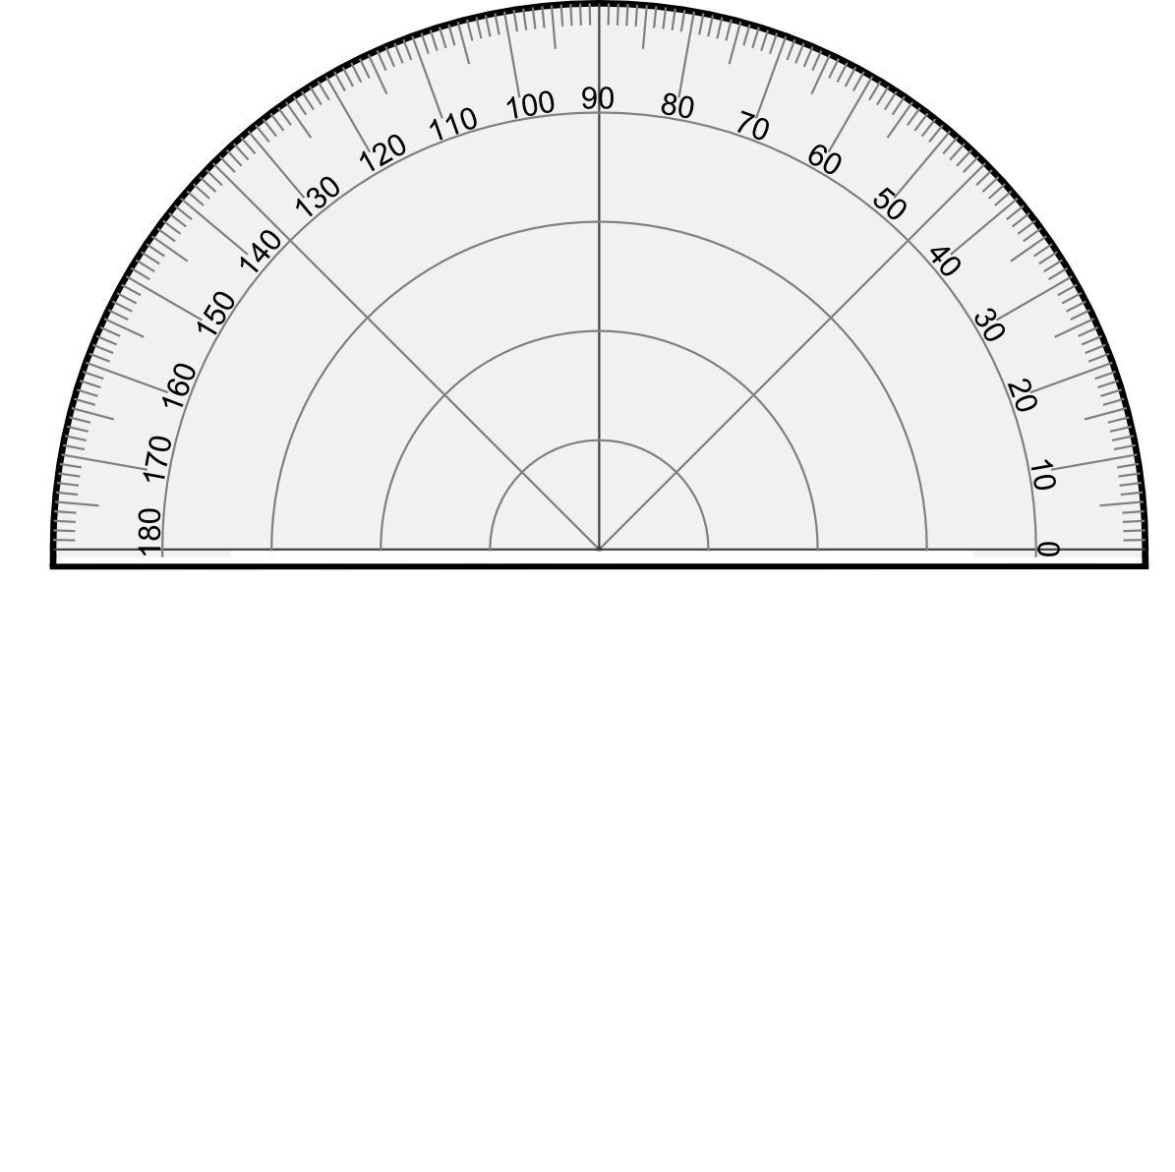
  - Mike used a protractor to measure $∠$ABC as shown below and said the result was exactly 130°. Do you agree or disagree? Explain your thinking.
A
B
C

  - Below is half of a line-symmetric figure and its line of symmetry. Use a ruler to complete Mike’s drawing.
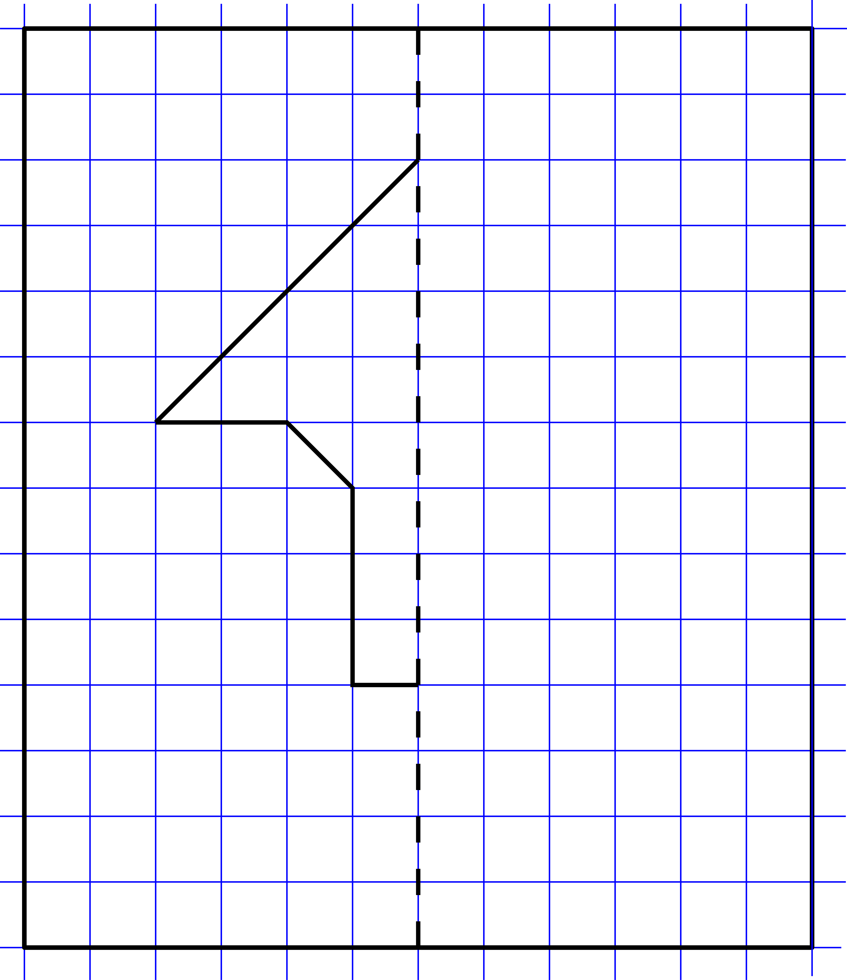

End-of-Module Assessment Task Topics A–D
Standards Addressed
Geometric measurements: understand concepts of angle and measure angles.
4.MD.5 Recognize angles as geometric shapes that are formed whenever two rays share a common endpoint, and understand concepts of angle measurement:
a. An angle is measured with reference to a circle with its center at the common endpoint of the rays, by considering the fraction of the circular arc between the points where the two rays intersect the circle. An angle that turns through 1/360 of a circle is called a “one-degree angle,” and can be used to measure angles.
b. An angle that turns through n one-degree angles is said to have an angle measure of n degrees.
4.MD.6 Measure angles in whole-number degrees using a protractor. Sketch angles of specified measure.
4.MD.7 Recognize angle measure as additive. When an angle is decomposed into non-overlapping parts, the angle measure of the whole is the sum of the angle measure of the parts. Solve addition and subtraction problems to find unknown angles on a diagram in real world and mathematical problems, e.g., by using an equation with a symbol for the unknown angle measure.
Draw and identify lines and angles, and classify shapes by properties of their lines and angles.
4.G.1 Draw points, lines, line segments, rays, angles (acute, right, obtuse), and perpendicular and parallel lines. Identify these in two-dimensional figures.
4.G.2 Classify two-dimensional figures based on the presence or absence of parallel or perpendicular lines, or the presence or absence of angles of a specified size. Recognize right angles as a category, and identify right triangles.
4.G.3 Recognize a line of symmetry for a two-dimensional figure as a line across the figure such that the figure can be folded along the line into matching parts. Identify line-symmetric figures and draw lines of symmetry.

Evaluating Student Learning Outcomes
A Progression Toward Mastery is provided to describe steps that illuminate the gradually increasing understandings that students develop on their way to proficiency. In this chart, this progress is presented from left (Step 1) to right (Step 4). The learning goal for each student is to achieve Step 4 mastery. These steps are meant to help teachers and students identify and celebrate what the student CAN do now and what they need to work on next.

A Progression Toward Mastery
Assessment  Task Item  and  Standards Assessed | STEP 1  Little evidence of reasoning without a correct answer.  (1 Point) | STEP 2  Evidence of some reasoning without a correct answer.  (2 Points) | STEP 3  Evidence of some reasoning with a correct answer or evidence of solid reasoning with an incorrect answer.  (3 Points) | STEP 4  Evidence of solid reasoning with a correct answer.  (4 Points)
1  4.G.2  4.G.3 | The student correctly answers fewer than five of the eight parts and shows little to no reasoning. | The student correctly completes at least five of the parts but shows little evidence of reasoning in Part (h). | The student correctly completes six or seven of the eight parts, providing sufficient reasoning in Part (h). Or, student answers all parts correctly but without solid reasoning in Part (h). | The student correctly draws all lines of symmetry, identifies figures with none, and answers Parts (g) and (h).  - 1 line.  - None.  - 3 lines.  - 4 lines.  - None.  - 2 lines.  - Triangle a is obtuse and isosceles.  Triangle c is acute and equilateral.  Triangle e is right and scalene.  - A circle has an infinite number of lines of symmetry. All lines of symmetry for a circle share the center point.
2  4.MD.7 | The student incorrectly determines the measure of angle RQS and provides little to no reasoning. | The student shows some evidence of a correct equation or adequate reasoning but miscalculates the angle measure. | The student correctly identifies 66 degrees, with some evidence of a correct equation or adequate reasoning. Or, the student uses reasoning and an equation correctly but miscalculates the angle measure. | The student correctly identifies that $∠$RQS and $∠$TQS total 90 degrees, so $∠$RQS measures 66 degrees, and includes an equation such as  24 + a = 90.
3  4.MD.5  4.MD.6  4.MD.7 | Student correctly answers fewer than three parts, providing no reasoning. | Student correctly answers at least one of the three parts, providing little reasoning. | Student correctly finds the measures for two of the three parts, providing solid reasoning. Or, the student solves correctly for all three parts, but only provides some reasoning. | Student correctly answers all three parts with solid reasoning:  - $∠$D = 277°. The number of degrees in a circle is 360, so $∠$D is the difference between 83 and 360.  - ∠QRT = 122°. A line equals 180 degrees, so ∠QRT must be equal to the difference between 180 and 58.  - ∠PRS = 122°. The measure of ∠TRS using $\overline{\text{QRS}}$ or ∠QRP using $\overline{\text{PRT}}$ is 58 degrees, making ∠PRS equal to the difference between 180 and 58.  The students may also determine that ∠PRS is equal to ∠QRT because of the two intersecting lines creating vertical angles. ∠QRV + ∠VRT = 122°. (Referencing vertical angles, although not necessary, is acceptable.)
4  4.MD.5  4.MD.6  4.MD.7  4.G.1  4.G.2  4.G.3 | The student correctly answers fewer than four of the eight parts. | The student correctly completes four or five of the parts. | The student correctly completes six or seven of the eight parts. | The student correctly answers all eight parts:  - Rectangle; 2 lines.  - Rhombus; 2 lines.  - Right, scalene triangle; no lines.  - Drawing depicts a right triangle with sides measuring  6 cm, 8 cm, and  10 cm.  - 270 degrees.  - 135 degrees;  45 + b = 180 or  180 – 45 = b.  - Mike lined the bottom ray up with the bottom edge of the protractor, not with the line that measures to zero.  - Drawing depicts a line-symmetric figure.

